AI ASSISTED CODING
LAB ASSIGNMENT –11.4
SAHASRA VEERAGONI
2403A53007
24BTCAICYB01-2-1

#TASK-1
- Use AI to help implement a Stack class in Python with the following operations: push(), pop(), peek(), and is_empty().

Prompt:
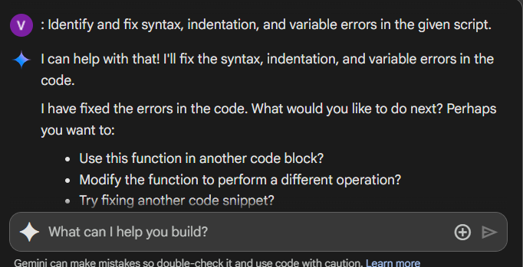
OUTPUT:
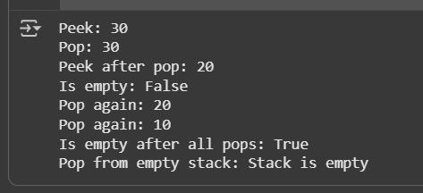

#TASK-2
Implement a Queue with enqueue(), dequeue(), and is_empty() methods
PROMPT:
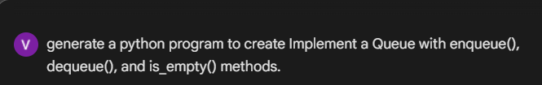

OUTPUT:
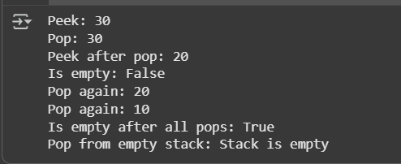

#TASK-3
: Implement a Singly Linked List with operations: insert_at_end(), delete_value(), and traverse().
PROMPT:
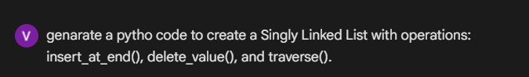
OUTPUT:
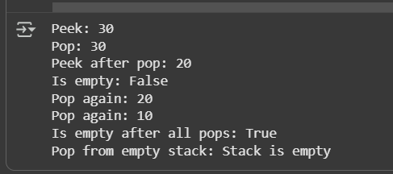

#TASK-4
: Implement a Binary Search Tree with methods for insert(), search(), and inorder_traversal().
PROMPT:
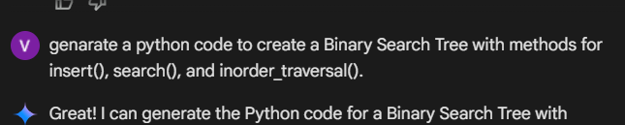

OUTPUT:

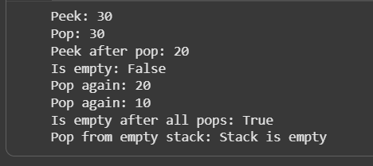

#TASK-5
Implement a Graph using an adjacency list, with traversal methods BFS() and DFS().

PROMPT:
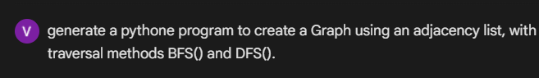

OUTPUT:
